Aim: Authentication attack using SETOOLKIT: To implement phishing using SE (Social engineering) Toolkit and understand its security concern

What is a Social Engineering Attack?
Social engineering is a form of psychological manipulation that tricks individuals into revealing sensitive information, bypassing security controls, or committing fraud. Unlike technical exploits that target system vulnerabilities, social engineering attacks target the human element, often the weakest link in any security chain.


What is a Phishing Attack?
Phishing is a type of social engineering attack where an attacker impersonates a trusted entity, such as a bank, email provider, or corporate portal, to deceive victims into revealing sensitive information like usernames, passwords, or credit card details. It typically involves sending fraudulent messages (via email, SMS, or social media) that lure users to fake websites designed to steal their credentials. Unlike technical exploits that target system flaws, phishing targets human trust and behavior, making it one of the most common and effective ways to breach security.

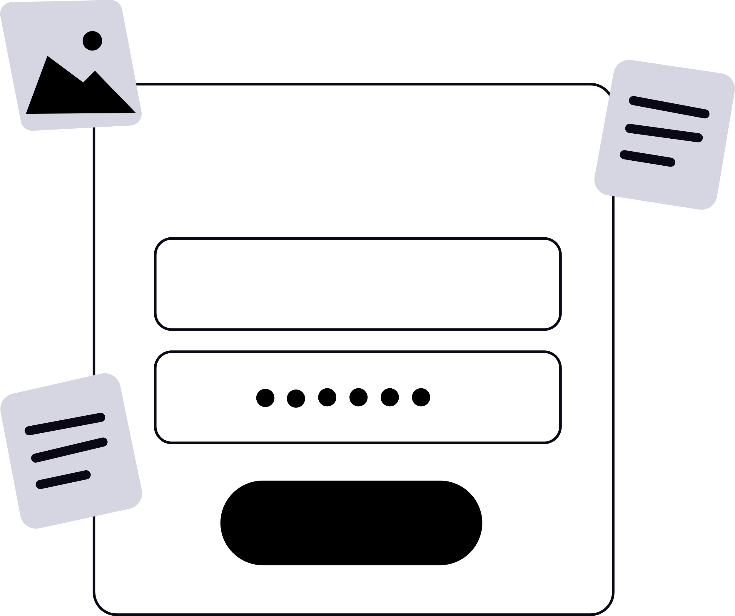
What is SETOOLKIT?
The Social-Engineer Toolkit (SET) is an open-source, Python-driven penetration testing framework specifically designed to simulate advanced social engineering attacks against the human element. Created by David Kennedy (TrustedSec), SET is pre-installed in Kali Linux and serves as a standard tool for security professionals conducting authorized social engineering assessments. The toolkit heavily relies on the Metasploit Framework for payload generation and delivery.

Objectives:
- Account takeover: Unauthorized access to victim accounts
- Data breach: Access to sensitive organizational or personal data
- Lateral movement: Using compromised credentials to access additional systems
- Financial fraud: Accessing financial accounts

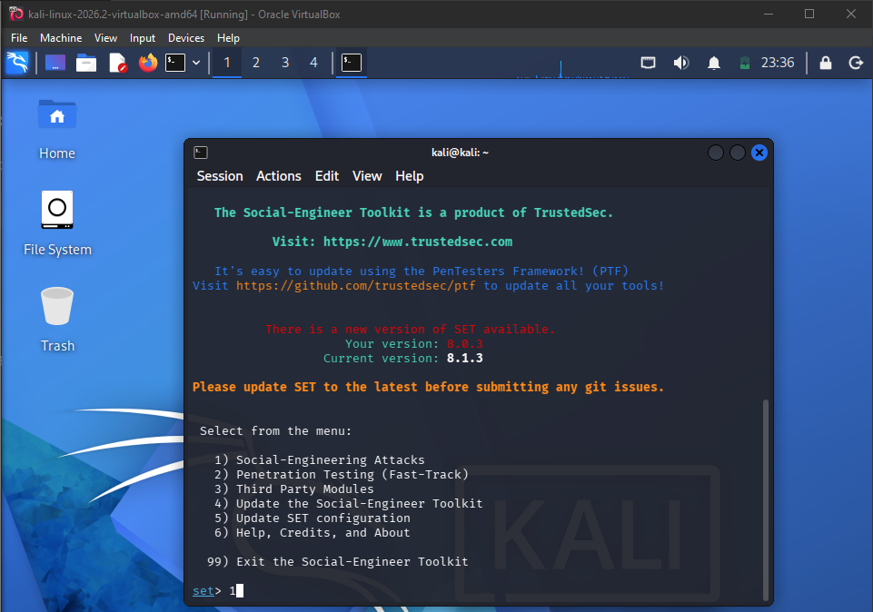
Kali Linux runs the Social-Engineer Toolkit for security testing.

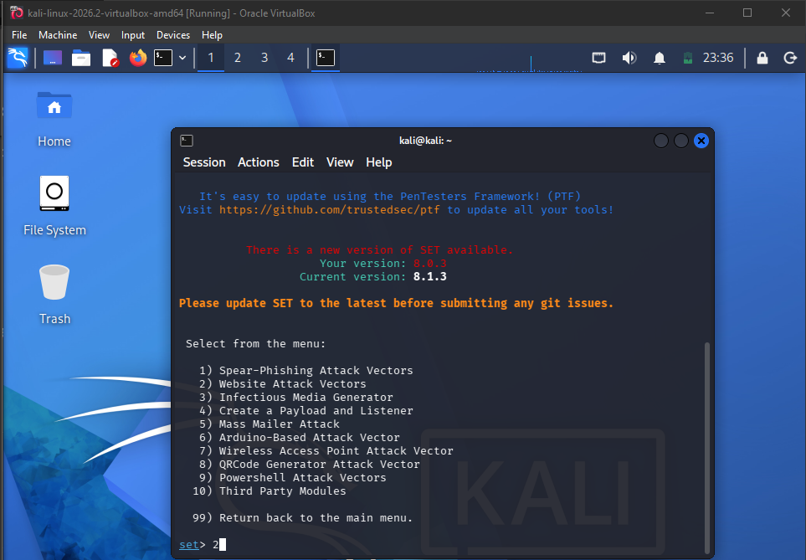
SET displays various social-engineering attack vectors for security testing.

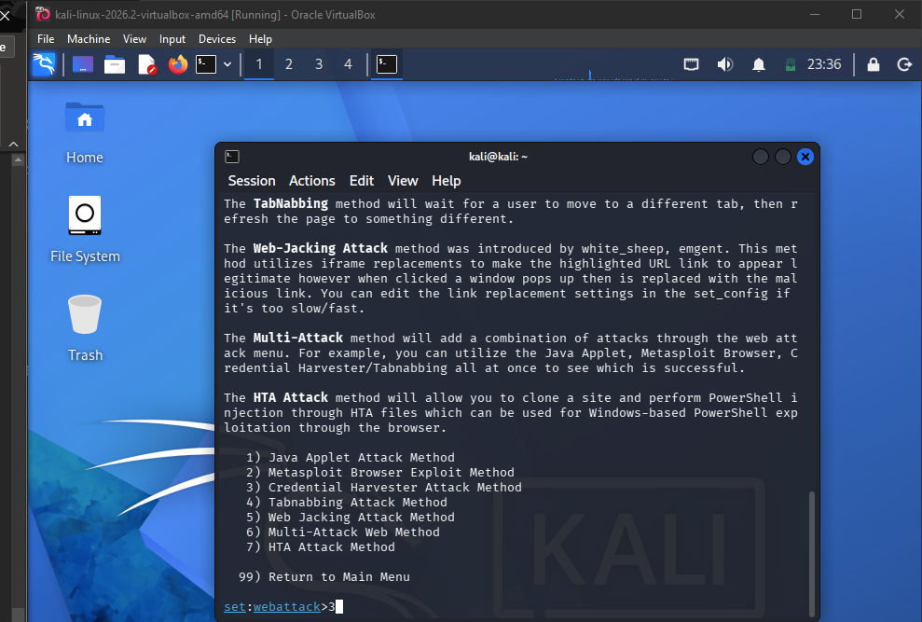
SET displays web-based attack methods, including tabnabbing and credential harvesting.

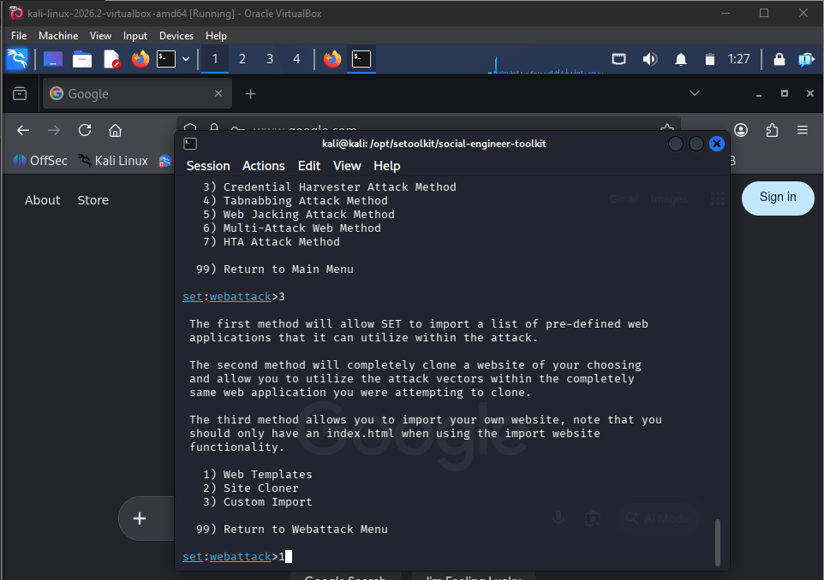
SET launches a web attack method, offering templates, cloning, and custom imports.

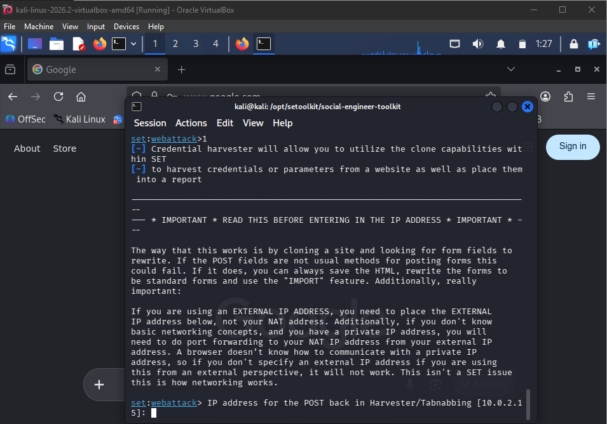
SET configures a credential-harvesting template and prepares its POST-back settings.

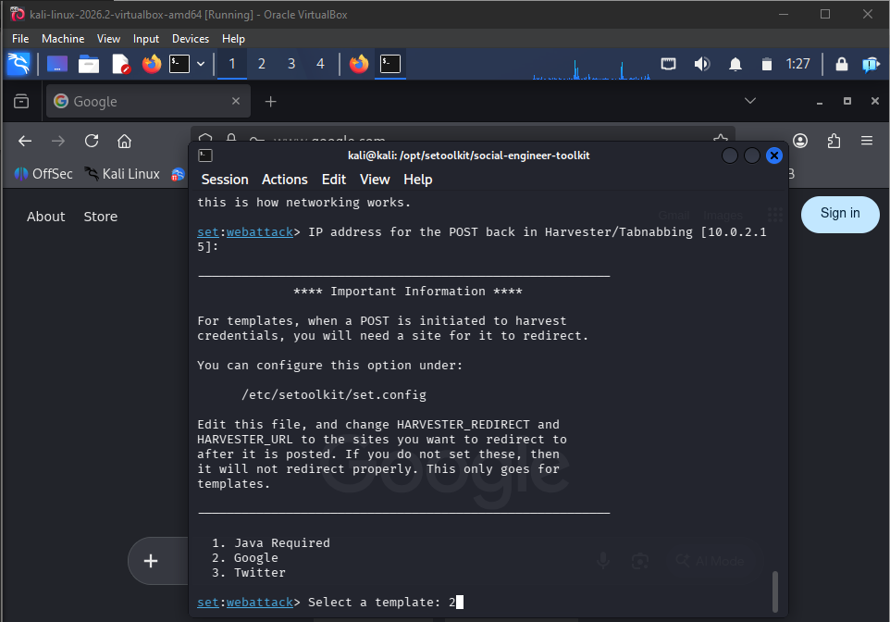
SET Toolkit cloning Google login page for credential harvesting attack.

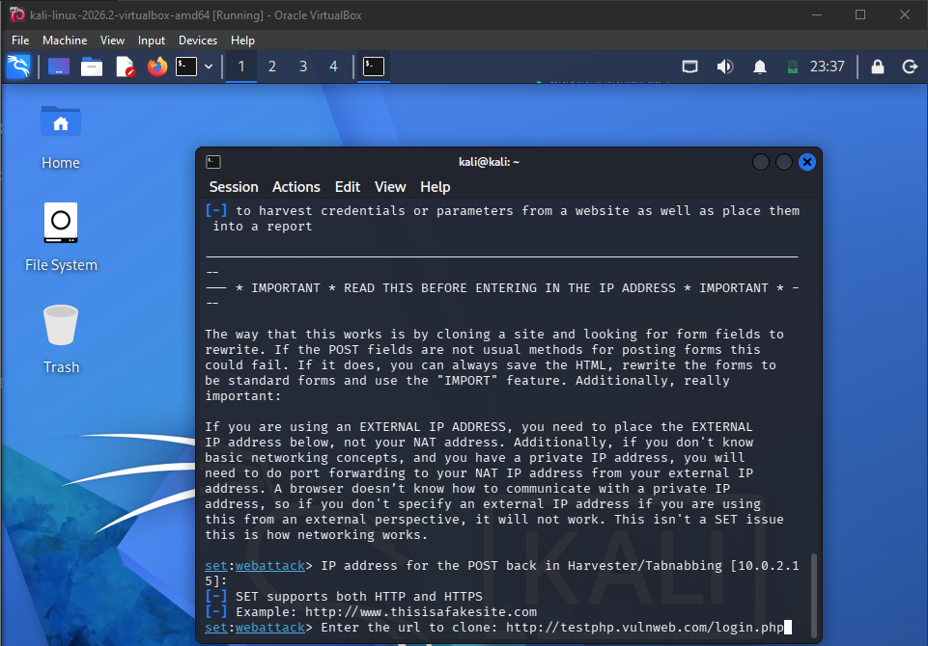
SET prompts for IP address and target URL to clone the login page.

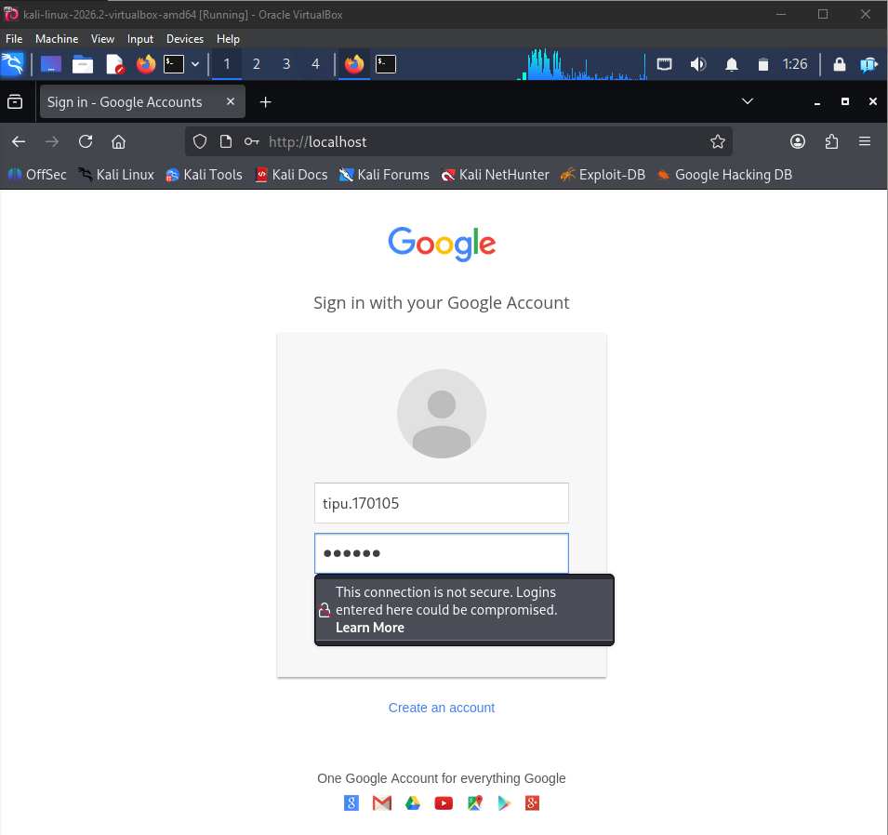
Cloned Google login page on localhost, warning of insecure connection.

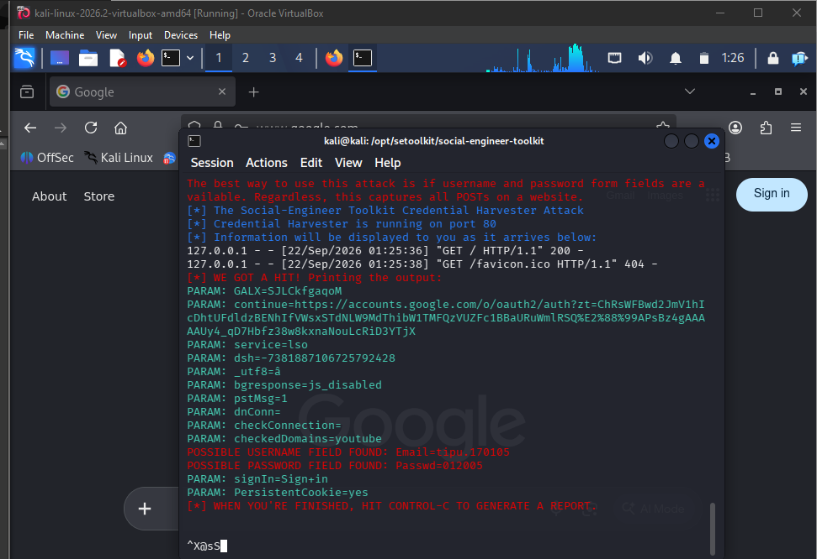
SET successfully captures victim's Google username and password in terminal.

Conclusion
Successfully demonstrated how the Social-Engineer Toolkit (SET) can be used to perform a credential harvesting attack by cloning a legitimate Google login page and capturing user credentials, highlighting how easily attackers can exploit human trust to bypass technical security controls. The exercise underscores the critical importance of security awareness training, Multi-Factor Authentication (MFA), and URL verification as essential defenses against phishing and social engineering threats.

